LOTW Review Quiz #A1-21
This is a review of lessons 15-20 from Light of the World English level A1 Beginner.
Please choose the best answer for each question.
My name is: ________________________________

1: This is my friend, Sara. She is _________.
▢ teacher
▢ an artist
▢ an doctor
▢ store owners

2: Joseph ___ a slave.
▢ were
▢ am
▢ was
▢ are

3: Were you at the pharmacy behind the school on Wednesday?
▢ No, I wasn't. I was at home.
▢ Yes, I am at the pharmacy now.
▢ No, they weren't behind the school.
▢ Yes, the school is between the pharmacies.

4: He is ______. He makes bread and sells it.
▢ a shepherd
▢ pastors
▢ a musician
▢ a baker

5: Can you please tell me where the park is?
▢ We don't park at the intersection.
▢ The hair salon is next to the restaurant.
▢ Yes, it has an emergency exit.
▢ It is east of the post office and across from the library.

6: Why do you wear glasses?
▢ Because I need to see to read.
▢ I put them in front of my eyes.
▢ I wear them on Wednesdays.
▢ We wear glasses in the kitchen.

7: How are you doing?
▢ Nothing.
▢ Not much.
▢ Good, thanks!
▢ Thank you very much.

8: What stores are near you?
▢ The library is near us.
▢ The grocery store is far.
▢ A men's clothing store and a food store are near me.
▢ He lives east of the store.

9: See you later!
▢ Hi, how are you?
▢ Hello. Good evening.
▢ Good night.
▢ Nice to meet you, too.

10: Where are the children?
▢ The kids are beside the bakery.
▢ The child was here yesterday.
▢ The boys and girls were late.
▢ They weren't at school in November.

11: Why were Joseph's brothers angry?
▢ Because their father loved Joseph more.
▢ The men live behind the hair salon.
▢ They weren't angry in January.
▢ Why they were near the bakery.

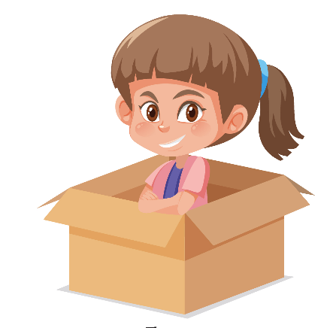
12: The kid is ______________ the box.
▢ under
▢ on
▢ in
▢ above

13: Fill in the blanks: August, _______, October, ______, December.
▢ September; November
▢ July; November
▢ September; April
▢ March; June

14: You did not hear your teacher. What would you say?
▢ Could you speak slower, please?
▢ I’m sorry. I don’t understand.
▢ Could you say that more slowly?
▢ Could you repeat that, please?

15: Who did God send to set his people free from Pharaoh, the king of Egypt?
▢ Noah
▢ Jonah
▢ Abraham
▢ Moses

16: We played ball with the kids at the ____________
▢ pharmacy
▢ park
▢ library
▢ grocery store

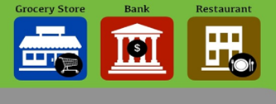
17: The bank is to the ___________ of the restaurant.
▢ left
▢ right
▢ between
▢ below

18: A _____________ works at a restaurant.
▢ doctor
▢ teacher
▢ nurse
▢ a server

19: There is ____________ on the table.
▢ an pen
▢ a book
▢ an ball
▢ a envelope

20: Choose the correct answer about the man's birthday circled on the calendar.
▢ His birthday wasn't in September.
▢ His birthday were Thursday.
▢ His birthday was on Monday.
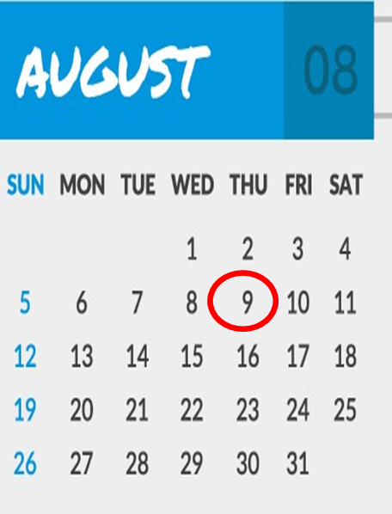
▢ His birthday was on August 10.

