LOTW Review Quiz #A1-28
This is a review of lessons 22-27 from Light of the World English Level A1.
Please choose the best answer for each question.
What is your name:

________________________________

1: Does he ___ vegetables?
▢ eats
▢ has
▢ have
▢ needs

2: Do we need bread from the store?
▢ Yes, he need bread.
▢ No, we have bread, but we need pizza.
▢ We doesn't need bread, but we need seafood.
▢ Yes, you has bread .

3: Do you like the yellow noodles?
▢ I doesn't like noodles.
▢ Yes, I likes it.
▢ No, I don't like them.
▢ Yes, you like the yellow noodles.

4: Whose family is it?
▢ Its my family.
▢ It's his family.
▢ It is their family's.
▢ Were your family.

5: Who is the baby?
▢ He is Mary's son.
▢ It is Mary's son.
▢ He is Marys son.
▢ She is Mary's son.

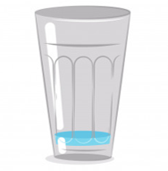
6: How much water do you have?
▢ I have a lot of water.
▢ I have a few water.
▢ I have a little water.
▢ I don't have any water.

7: How often does she drink coffee?
▢ They never has coffee in the morning.
▢ She sometimes have coffee in the morning.
▢ He always drinks coffee in the morning.
▢ She always has coffee in the morning.

8: What did the Spirit of God look like after Jesus was baptized?
▢ A white bird.
▢ A friend.
▢ An angel.
▢ John the Baptist.

9: Does the boy brush his teeth?
▢ Yes, he brushed his teeth every morning.
▢ Yes, he brushes his teeth every morning.
▢ Yes, he brush his teeth every morning.
▢ Yes, he has brushed his teeth every morning.

10: What does she do after school?
▢ She does homework.
▢ She do homework.
▢ She did homework.
▢ She didn't do homework.

11: Our mother makes ...
▢ coffee
▢ laundry
▢ dishes
▢ homework

12: Our sister does ...
▢ laundry
▢ rice
▢ money
▢ mistakes

13: He ____ the whole world in ________ hands.
▢ He have the whole world in his hands.
▢ He has the whole world in his hands.
▢ He has the whole world in my hand.
▢ He have the whole world in her hands.

14: Which numbers are next? 10, 11, ...
▢ 14, 15, 13, 12
▢ 12, 14, 13, 15
▢ 12, 13, 14 , 15
▢ 13, 12, 15, 14

15: My father's mother is my ________
▢ wife
▢ grandfather
▢ mother
▢ grandmother

16: Every day he ______________________.
▢ wakes up, brushed his teeth, gets dressed, and goes to work.
▢ wakes up, brushes her teeth, gets dressed, and goes to work.
▢ wakes up, brushes his teeth, gets dressed, and goes to work.
▢ wake up, brush the teeth, get dressed, and go to work.

17: Who baptized Jesus?
▢ The angels
▢ John the baptist.
▢ Joseph and Mary
▢ The shepherds

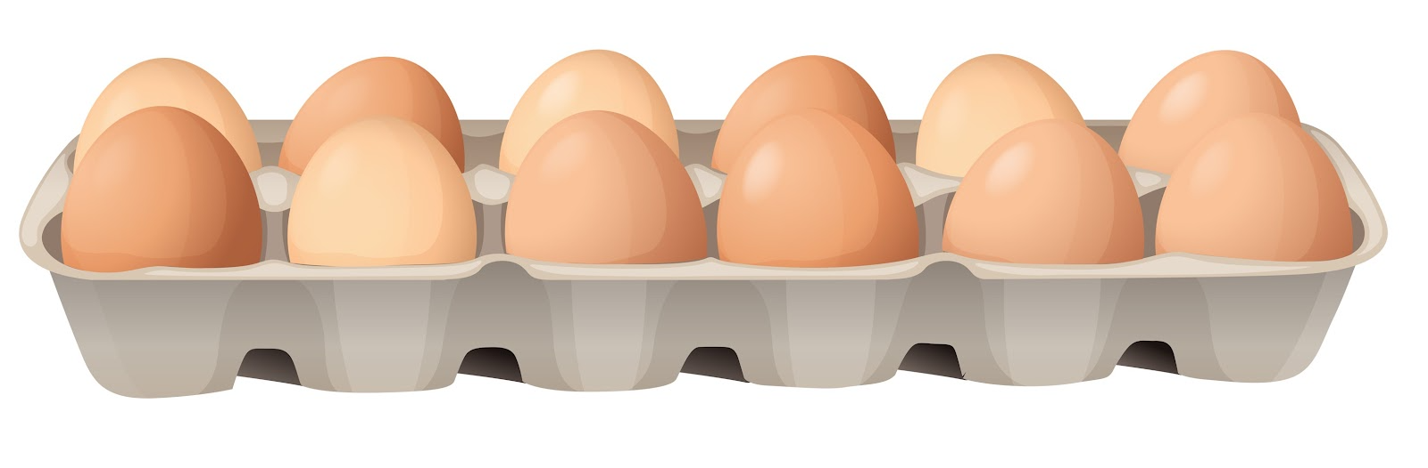
18: How many eggs do you see?
▢ I don't see any eggs.
▢ I see much eggs.
▢ I see a little eggs.
▢ I see many eggs.

19: The boys brush _________ teeth.
▢ our
▢ their
▢ my
▢ his

20: What do you see?

▢ She types on the computer.
▢ She type on the laptop.
▢ She types on the mobile phone.
▢ They types on the mobile phone.

