LOTW Review Quiz #A1-49
This is a review of lessons 43-48 from Light of the World English Level A1.
Please choose the best answer for each question.
What’s your name?

________________________________

1. Is the truck bigger than the car? 
▢ No, his truck is big.
▢ Yes, it's bigger than the car.
▢ Yes, the car is bigger than the truck.
▢ No, it is smaller than the car.

2. How much is the ticket to Rome?
▢ I drive to Rome.
▢ The ticket are cheap.
▢ The ticket costs 12 euros.
▢ I don't sell ticket.

3. How would you like to travel?
▢ I like would walk.
▢ I'd like to travel by plane.
▢ I don't like buses.
▢ The car is fast.

4. Would you like a receipt?
▢ Yes, I would.
▢ No problem.
▢ I want receipt.
▢ I'd like to travel by car.

5. Does she like to play soccer?
▢ Yes, she would.
▢ She like to exercise.
▢ No, she doesn't like to play soccer.
▢ She plays soccer.

6. Is it going to snow tomorrow?
▢ No, it not snow.
▢ Yes, she is.
▢ Yes, it's going to snow.
▢ I'm not going because it's snowing.

7. What is he going to do this weekend?
▢ He not going to study his lessons.
▢ He is going to study his lessons.
▢ He doesn't like to study his lessons.
▢ He'd study his lessons.

8: Are we going to school today?
▢ No, we not go.
▢ No, we is going to school.
▢ No, we are not going to school today.
▢ No, we wouldn't go to school today.

9. Are you gonna celebrate your birthday?
▢ Yes, I'm gonna celebrate my birthday.
▢ Yes, we are gonna have a big cake.
▢ No, I not gonna celebrate my birthday.
▢ Yes, I like party.

10. What are you gonna do with the ribbons?
▢ I like ribbons.
▢ I wouldn't wrap the gift.
▢ I am gonna wrap the gift.
▢ I wrapping the gift.


11. Her hair is ___________ than his.
▢ taller
▢ long
▢ longer
▢ shorter

12. Which sentence is correct?
▢ God said “I have heard your prayers.”
▢ God said, “I have heard your prayers.”
▢ God said, I have heard your prayers.
▢ God, Said, I have heard your prayers"

13. There are going to be __________ tomorrow.
▢ rain
▢ drought
▢ tornado
▢ clouds

14. Which book does she prefer?
▢ The book is thick.
▢ She prefers the thicker book.
▢ She prefer the thick book.
▢ I don't like to read.

15. Do you walk to work?
▢ No, he's gonna fly.
▢ Yes, I take the bus.
▢ Yes, I like to work.
▢ No, I take the bus.

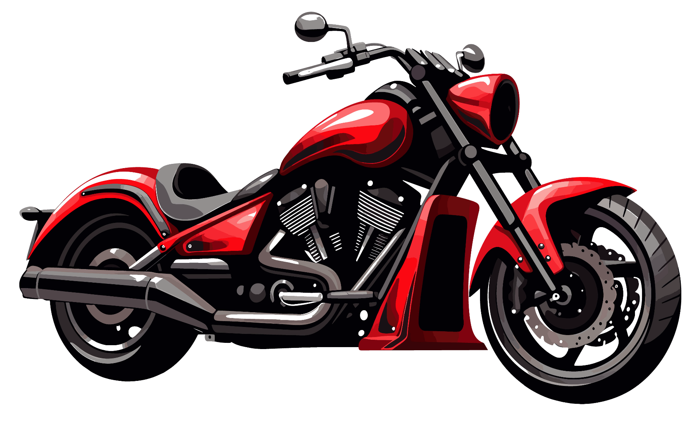
16. He would like to travel by ___________ .
▢ motorcycle
▢ bicycle
▢ train
▢ bus

17. Does this train go to the beach?
▢ No, it goes to the city.
▢ Yes, it doesn't.
▢ Would you like to buy a ticket.
▢ I don't like to travel by train.

18. What is going to happen?
▢ She likes to eat cake.
▢ She would like to eat cake.
▢ She is going to eat cake.
▢ She eats cake.

19. I like snow _____ than rain.
▢ best
▢ better
▢ good
▢ worse

20. Which sentence is correct?
▢ "Jesus said, I am the light of the world"
▢ Jesus, said I am the light of the world,
▢ Jesus said "I am the light of the world".
▢ Jesus said, "I am the light of the world."

